**Exp.: 2 Addressing Modes**

1. **Immediate Addressing Mode**

**Code**

ORG 000H

MOV A, #20H

MOV B, #10H

END

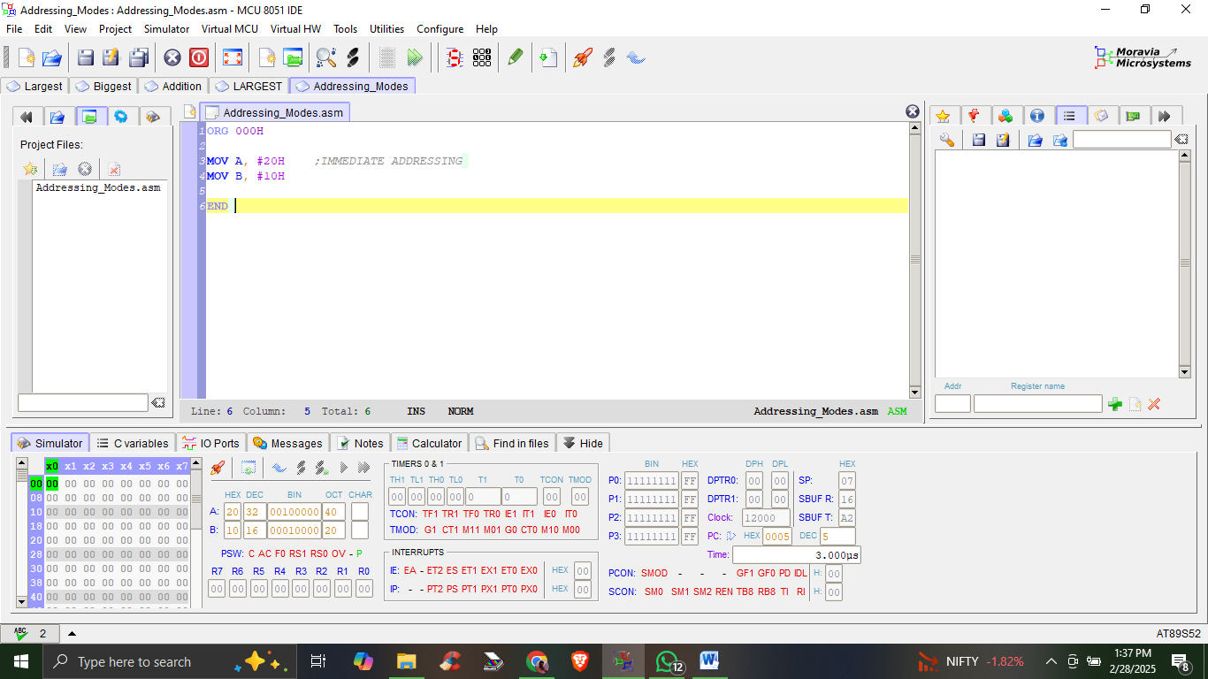

1. **Register Addressing Mode**

**Code**

ORG 000H

;REGISTER ADDRESSING MODE

MOV R0, #10H ; HEXADECIMAL NUMBER

MOV A, R0

MOV R1, #100 ; DECIMAL NUMBER

MOV B, R1

END

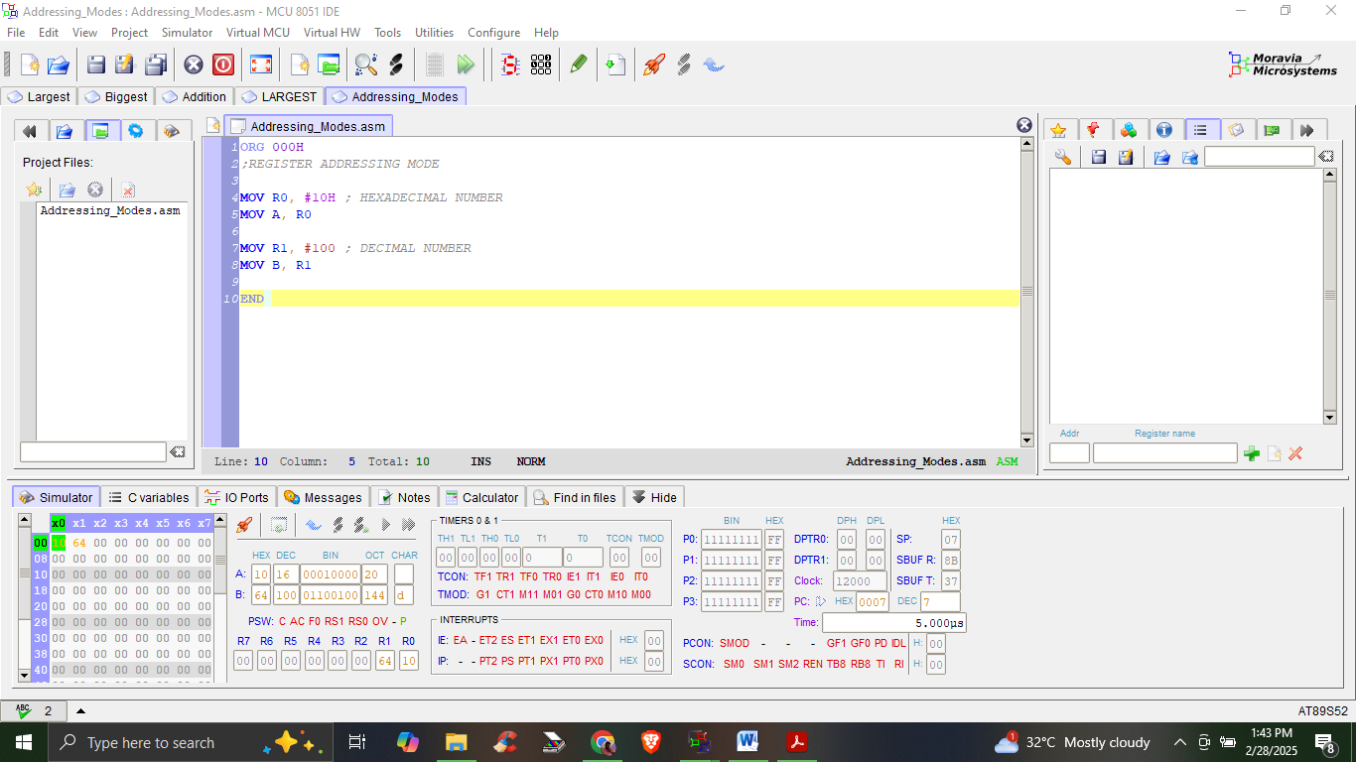

1. **Direct Addressing Mode**

**Code**

ORG 0000H ; Origin directive, sets the starting address to 0000H

MOV 30H, #55H ; Store the immediate value 55H into memory address 30H

MOV A, 30H ; Move the value at memory address 30H to the accumulator (A)

MOV 40H, A ; Move the value in the accumulator (A) to memory address 40H

END ; End of the program

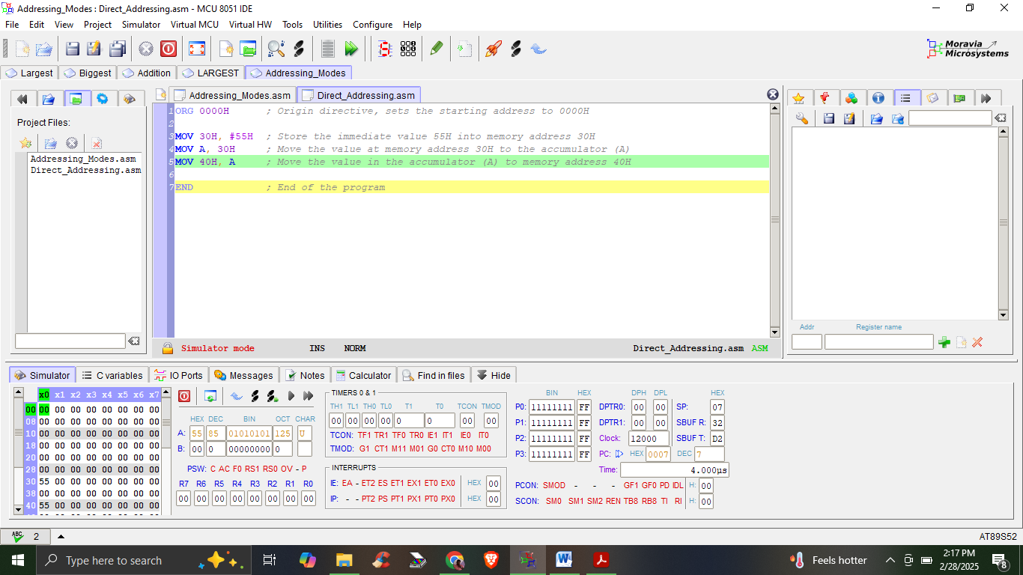

1. **Indirect Addressing Mode**

**Code**

ORG 0000H ; Origin directive, sets the starting address to 0000H

MOV A, #55H ; Load the accumulator (A) with the immediate value 55H

MOV R0, #30H ; Load register R0 with the address 30H

MOV @R0, A ; Store the value in the accumulator (A) to the address in R0 (30H)

MOV R1, #40H ; Load register R1 with the address 40H

MOV A, @R0 ; Move the value at the address in R0 (30H) to the accumulator (A)

MOV @R1, A ; Store the value in the accumulator (A) to the address in R1 (40H)

END ; End of the program

